Emma White
Emma.L.White@northumbria.ac.uk

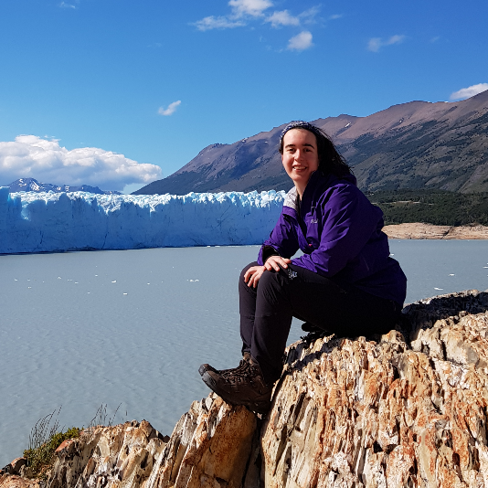
Why did you choose to study with the ONEPlanet DTP? What are you researching?

My research will be focused on the Western Bellingshausen Sea in Antarctica. In this region, warm water is found on the continental shelf, where it can lead to enhanced melting of ice shelves. My research will focus on questions such as how is this warm water transported onto the continental shelf, how does it reach the ice shelves in the region, and what impact does the warm water have on the melting of the ice shelves?

What do you think are the key benefits of your postgraduate study?

During my PhD, I hope to improve my knowledge of oceanography and Antarctica and develop my research skills. I look forward to the opportunity to work with and learn from scientists in a field that is of great interest to me.

How will your current research/study help you achieve your career ambitions?

I enjoy research, and am still considering future career paths. I hope that during the process of my PhD I will develop my career plans, including through OnePlanet events such as the RAC and OnePlanet conference.

What impact will your current research achieve?

West Antarctica is a marine based ice sheet, which makes it more vulnerable to oceanic melting. There is relatively limited observational data in the Western Bellingshausen Sea, so this work will contribute to current understanding of the region. This vulnerability to oceanic melting combined with the limited observational data makes it particularly important to understand the processes occurring here that can contribute to the melting of ice shelves.

Anything else you would like to tell us?

(For example, have you become a student ambassador, gained any work experience, joined any clubs, societies or teams, reached any personal goals, or have any other comments you’d like to make?)

